**React Assignment**

**Reference Notes**

**Task 1:**

Create a react app which captures the user click on the area of the card area.

Following points are the requirements for the application.

1. It should have a card area which displays the number of clicks in the center.
2. Background color of the card should randomly change on each click. You are free to choose the colors.
3. There should be three buttons below the card.
   1. **+ button =>**  This button should add to the number of clicks to the card area.
   2. **- button =>** This button should reduce the number of clicksto the card area.
   3.  button => Refresh button should make the number of clicks on the card to 0 and set the background to white.

**Refer the image below:**

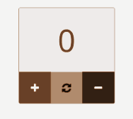

**Following pointers are important:**

1. Create components which can hold state.
2. Attach events on the button area.
3. Keep track of the state and update it on the card.
4. Update the background color on every click.

**Deadline: 2nd December.**